Year 12 ATAR Biology

Task 2 Extended Response GM Bananas

Validation Test /20 (weight 50%, weight of research 50%) Total mark_________________ Name………………………………………………………..
Botanists in Queensland are developing genetically modified bananas that can boost vitamin and mineral content.
- What does Genetically Modified food mean? Give 2 foods examples except bananas ( 5 marks)
Genetically modified organisms (GMOs) can be defined as organisms (i.e. plants, animals or microorganisms) in which the genetic material (DNA) has been altered in a way that does not occur naturally by mating and/or natural recombination. (3marks)
Genes for nutrition : Examples Golden rice contains the gene for beta-carotene, a precursor for vitamin A, Soybeans, herbicide resistance, ripened tomatoes. (2marks)

- Describe the process of cloning in plants that could be used to produce bananas that can boost vitamin and mineral content. Include labeled diagrams. ( 15 marks)
To transfer genes into another organism, the genes need to be delivered in such a way that they can be active (expressed) in that organism. Vectors are tools that can transport DNA from one organism to another. Plasmids can be used as vectors. Agribacteria is the type of bacteria used to transfer the DNA of desired bananas into host the cell
Copying DNA using plasmids is called genetic cloning. The process involves the following steps. (7 marks)
- Extracting plasmids from bacterial cells by rupturing (lysing) them
- Cutting the plasmid with restriction enzymes
- Cutting the DNA fragment to be inserted with the same restriction enzymes (to give the same sticky ends)
- Incubating the cut fragment and plasmid together with DNA ligase
- Inserting the plasmid into bacterial cells, in this case agribacteria. This is called transformation.
- Selecting transformed bacteria by growing them in antibiotic-containing media.
- Growing out: Introducing plasmid into plant cell like banana can be difficult because of cell wall & it has to go into nucleus – Electroporation electric impulse or Biolistic – micro projectile, gun method to shatter cell wall- small fragments of tungsten. Can be inserted into shoot of plant or grown in tissue culture (sterile nutrient agar)
Plant material, growing medium and other equipment must be kept sterile to prevent bacterial, fungal or viral growth, damaging the developing plant material.
Process showing cloning as in a banana plant
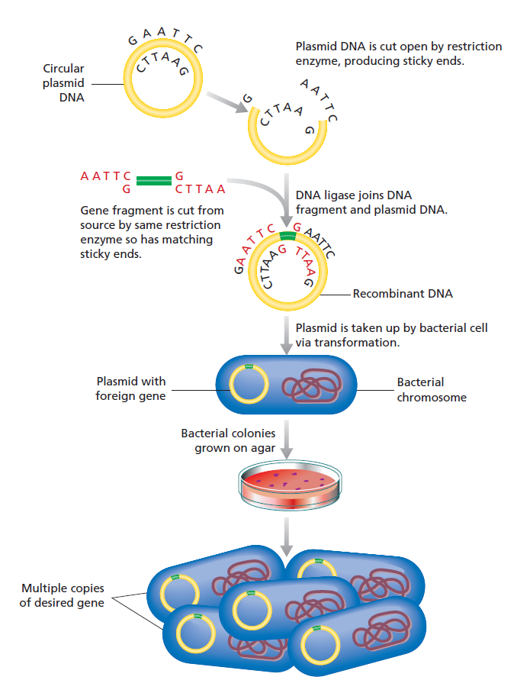
Target gene from resistant or nutritious banana
Agribacteria is the vector for banana

(6 marks)

Antibiotic selection (Step 6 above)
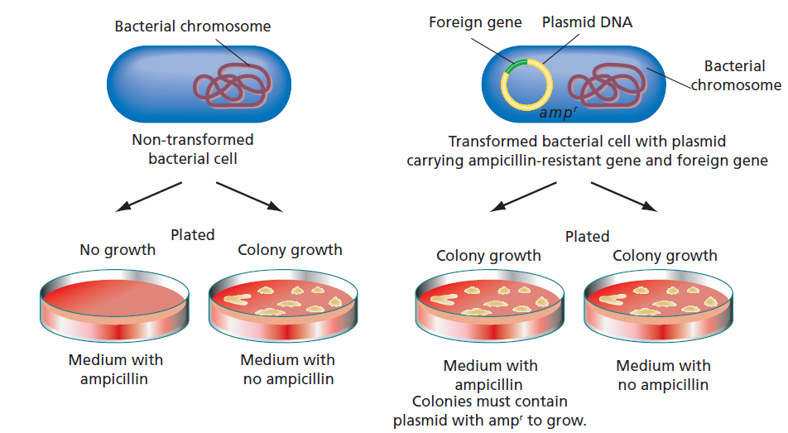
Transformed bacteria can grow equally well on either media
(2 marks)

